Magnetic Fields due to

Different Current-carrying Conductors
1. (a) What is the magnetic field pattern around a current-carrying straight wire when the current points into the paper? Draw the field pattern in the space provided.

(b) What is the effect to the magnetic field pattern if the current carried by the wire increases?

2. For an infinitely long solenoid, investigate the magnitude of magnetic field inside the current-carrying solenoid by using the magnetic field meter. What do you observe?

3. The following magnetic field pattern is obtained for a pair of straight wires.
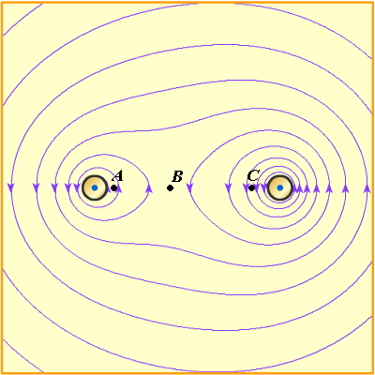 Fig. Q3
The current carried by wire 1 (on the left) is 2 A, the current carried by wire 2 (on the right) is 3 A and the separation of the wire is 30 cm. It is found that the densities of field lines at points A, B, and C in Figure Q3 are different. Drag the magnetic field meter to these points and compare the fields at these points. Then try to deduce the relation between the density of field lines and the magnitude of magnetic field.

Magnetic Fields due to

Different Current-carrying Conductors (Answers)
1. (a) What is the magnetic field pattern around a current-carrying straight wire when the current points into the paper? Draw the field pattern in the space provided.
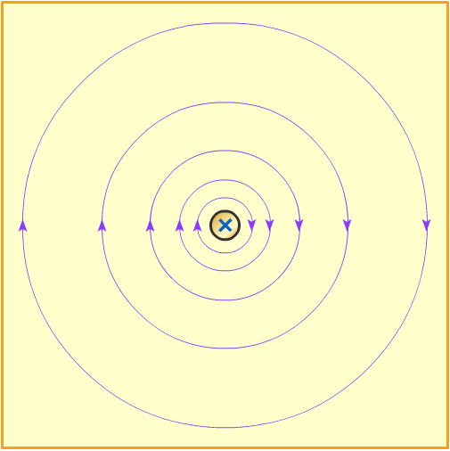
(b) What is the effect to the magnetic field pattern if the current carried by the wire increases?
If the current increases, the density of magnetic field lines also increases.

2. For an infinitely long solenoid, investigate the magnitude of magnetic field inside the current-carrying solenoid by using the magnetic field meter. What do you observe?
The magnitude of magnetic field is constant inside the solenoid.

3. The following magnetic field pattern is obtained for a pair of straight wires.
Fig. Q3
The current carried by wire 1 (on the left) is 2 A, the current carried by wire 2 (on the right) is 3 A and the separation of the wire is 30 cm. It is found that the densities of field lines at points A, B, and C in Figure Q3 are different. Drag the magnetic field meter to these points and compare the fields at these points. Then try to deduce the relation between the density of field lines and the magnitude of magnetic field.
It is found that the magnitude of magnetic field is the greatest at point C, while it is the least at point B. From the above observation, when the density of field lines increases, the magnitude of magnetic field also increases.

