Image Formation by a Concave Lens

1. Vary the object distance and note the nature of the images formed.
(Hint: You can vary the object distance by dragging the object or the slide bar at the bottom.)
Do the images have the same nature?

What is the nature of the images?
(Press  to display a grid which helps you to compare the sizes of the object and image.)

2. Position the object within the focal length as shown. Then, drag the object away from the lens.
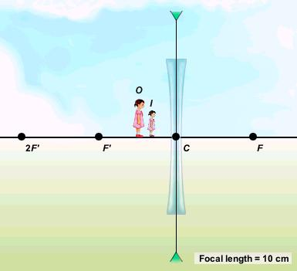
How does the size of the image change?

Image Formation by a Concave Lens (Answers)

1. Vary the object distance and note the nature of the images formed.
(Hint: You can vary the object distance by dragging the object or the slide bar at the bottom.)
Do the images have the same nature?
Yes.

What is the nature of the images?
(Press to display a grid which helps you to compare the sizes of the object and image.)
Virtual, erect and diminished.

2. Position the object within the focal length as shown. Then, drag the object away from the lens.
How does the size of the image change?
The size of the image decreases.

