Image Formation by a Convex Lens

1. Vary the object distance u and note the nature of the images formed. Record the results in the table below.
(Hint: You can vary the object distance by dragging the object or the slide bar at the bottom. Press  to display a grid which helps you to compare the sizes of the object and image.)

Object distance u  / cm | u < f | f < u < 2f | u = 2f | u > 2f
Nature of image
real / virtual
erect / inverted
magnified / same size as the object / diminished

2. Position the object within the focal length as shown. Then, drag the object slightly away from the lens.
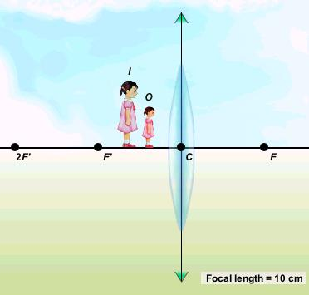
How does the size of the image change?

3. Position the object just beyond the focal length as shown. Then, drag the object away from the lens.
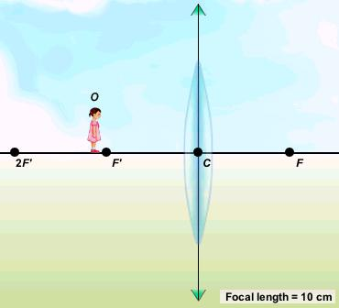
How does the size of the image change?

Image Formation by a Convex Lens (Answers)

1. Vary the object distance u and note the nature of the images formed. Record the results in the table below.
(Hint: You can vary the object distance by dragging the object or the slide bar at the bottom. Press to display a grid which helps you to compare the sizes of the object and image.)

Object distance u  / cm | u < f | f < u < 2f | u = 2f | u > 2f
Nature of image
real / virtual | virtual | real | real | real
erect / inverted | erect | inverted | inverted | inverted
magnified / same size as the object / diminished | magnified | magnified | same size as the object | diminished

2. Position the object within the focal length as shown. Then, drag the object slightly away from the lens.
How does the size of the image change?
The size of the image increases.

3. Position the object just beyond the focal length as shown. Then, drag the object away from the lens.
How does the size of the image change?
The size of the image decreases.

