Interference of Water Waves

1. Generate two sets of waves with short wavelengths, and a small source separation. Observe the wave pattern carefully.
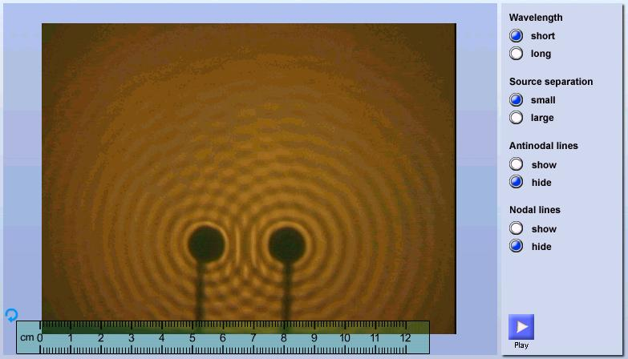
2. Select waves with long wavelengths.
How does the wave pattern change?

3. Select a large source separation.
How does the wave pattern change in this case?

Interference of Water Waves (Answers)

1. Generate two sets of waves with short wavelengths, and a small source separation. Observe the wave pattern carefully.
2. Select waves with long wavelengths.
How does the wave pattern change?
The separation between antinodal lines and nodal lines increases.

3. Select a large source separation.
How does the wave pattern change in this case?
The separation between antinodal lines and nodal lines decreases.

