Kinetic Theory Model
1. Keep the pressure p constant and increase the temperature T at regular intervals.
(a) Describe any changes in the average speed of the gas molecules, the space occupied by the molecules and their frequency of hitting the wall of the container, if any.

(b) Plot a graph of volume V against temperature T on the graph paper below. Hence, deduce the relation between volume V and temperature T of a fixed mass of gas at a constant pressure.



2. Keep the volume V constant and increase the temperature T at regular intervals.
(a) Describe any changes in the average speed of the gas molecules and their frequency of hitting the wall of the container, if any.

(b) Plot a graph of pressure p against temperature T on the graph paper below. Hence, deduce the relation between pressure p and temperature T of a fixed mass of gas at a constant volume.

3. Keep the temperature T constant and increase the volume V at regular intervals.
(a) Describe any changes in the average speed of the gas molecules and their frequency of hitting the wall of the container, if any.

(b) Plot a graph of pressure p against the reciprocal of volume, 1/V, on the graph paper below. Hence, deduce the relation between pressure p and volume V of a fixed mass of gas at constant temperature.

4. Increase the number of moles of the gas n from 0.5 to 1.0. Plot a graph of pV/T against n on the graph paper below. How do these two quantities relate to each other?

Kinetic Theory Model (Answers)
1. Keep the pressure p constant and increase the temperature T at regular intervals.
(a) Describe any changes in the average speed of the gas molecules, the space occupied by the molecules and their frequency of hitting the wall of the container, if any.
The average speed of the gas molecules and the space occupied increase together. However the frequency of hitting the wall remains about the same.

(b) Plot a graph of volume V against temperature T on the graph paper below. Hence, deduce the relation between volume V and temperature T of a fixed mass of gas at a constant pressure.
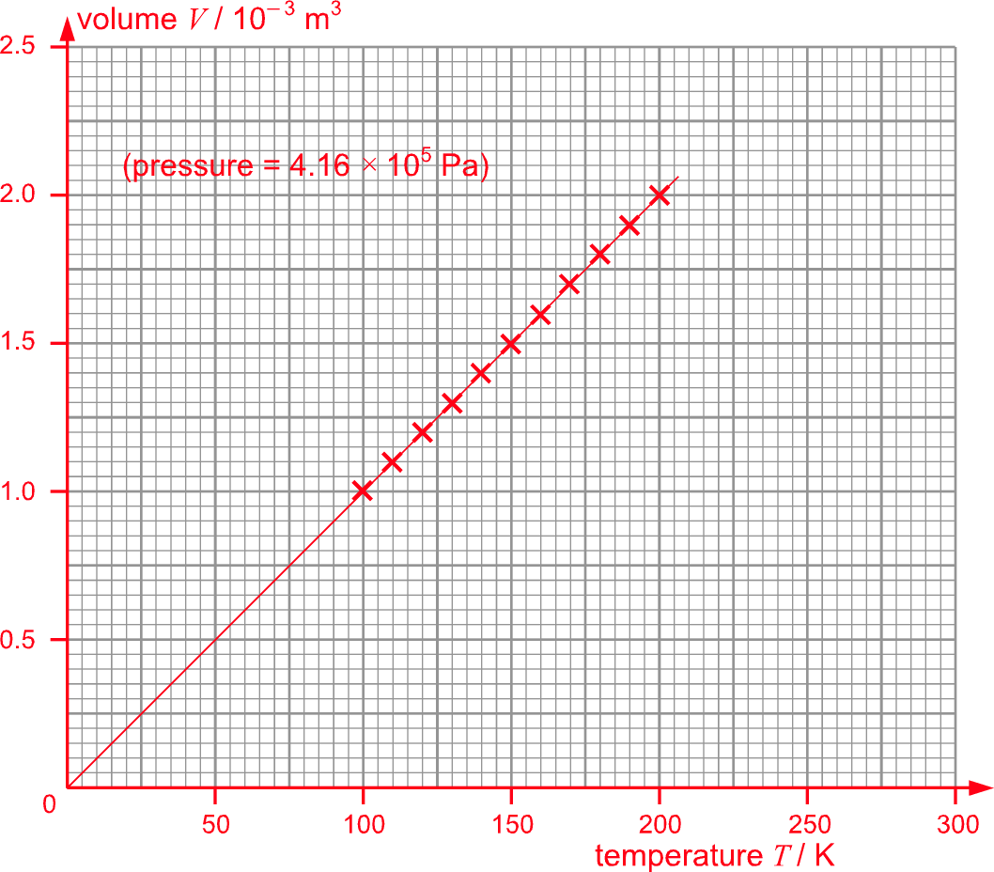
The volume V of a fixed mass of gas is directly proportional to its Kelvin temperature T at a constant pressure.

2. Keep the volume V constant and increase the temperature T at regular intervals.
(a) Describe any changes in the average speed of the gas molecules and their frequency of hitting the wall of the container, if any.
The average speed of the gas molecules and their frequency of hitting the wall of the container increase together.

(b) Plot a graph of pressure p against temperature T on the graph paper below. Hence, deduce the relation between pressure p and temperature T of a fixed mass of gas at a constant volume.
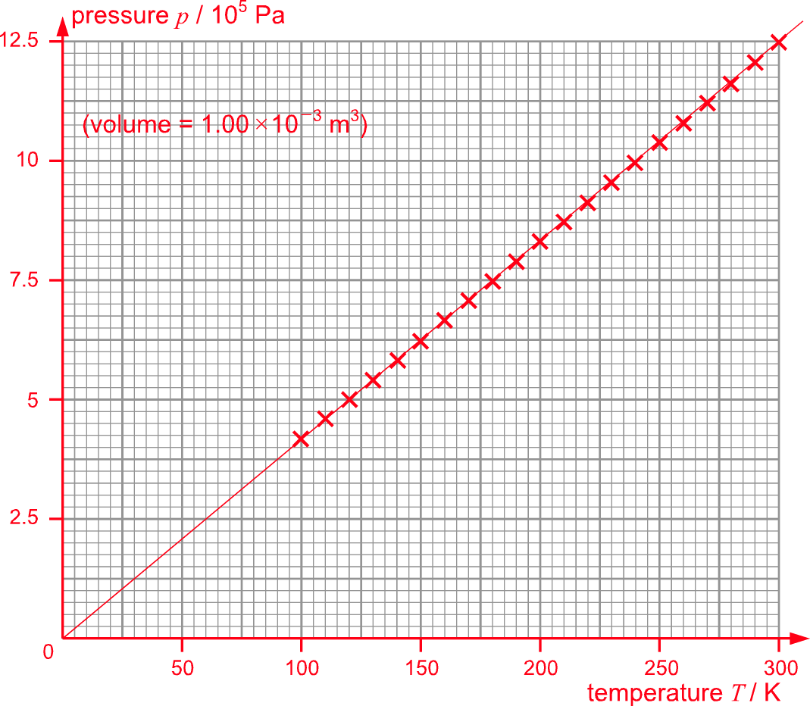
The pressure p of a fixed mass of gas is directly proportional to its Kelvin temperature T at a constant volume.

3. Keep the temperature T constant and increase the volume V at regular intervals.
(a) Describe any changes in the average speed of the gas molecules and their frequency of hitting the wall of the container, if any.
The average speed of the molecules remains unchanged while their frequency of hitting the wall of the container decreases.

(b) Plot a graph of pressure p against the reciprocal of volume, 1/V, on the graph paper below. Hence, deduce the relation between pressure p and volume V of a fixed mass of gas at constant temperature.
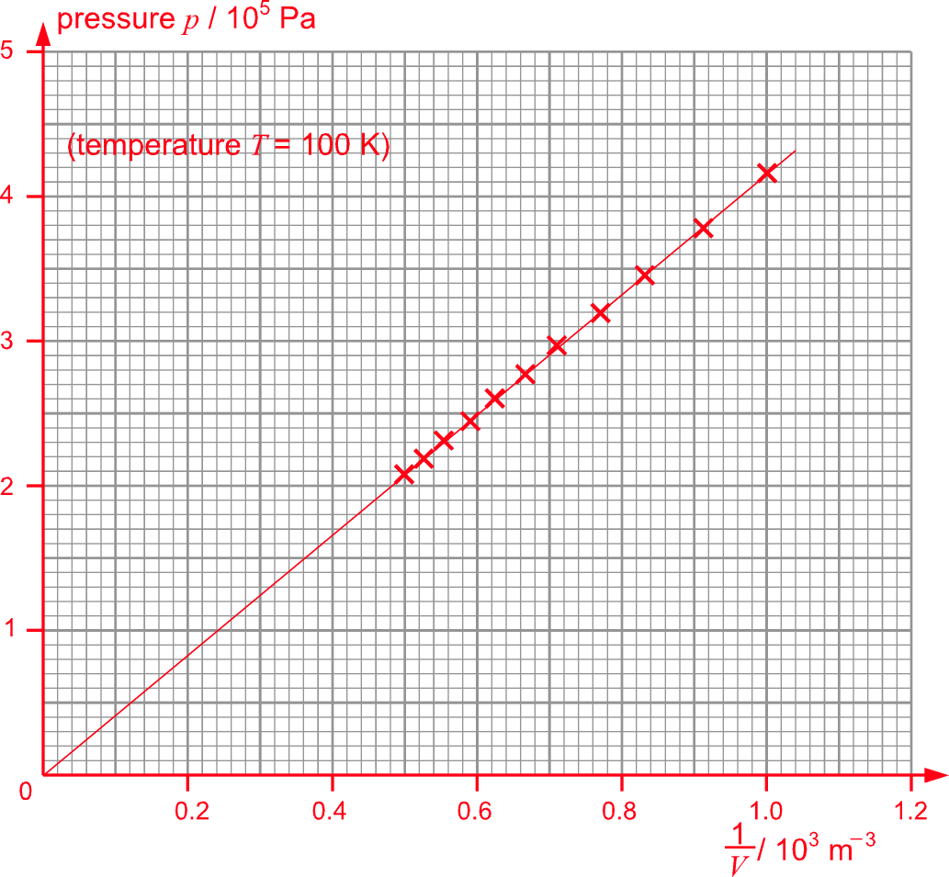
The pressure p of a fixed mass of gas is inversely proportional to the volume V of a fixed mass of gas at constant temperature.

4. Increase the number of moles of the gas n from 0.5 to 1.0. Plot a graph of pV/T against n on the graph paper below. How do these two quantities relate to each other?
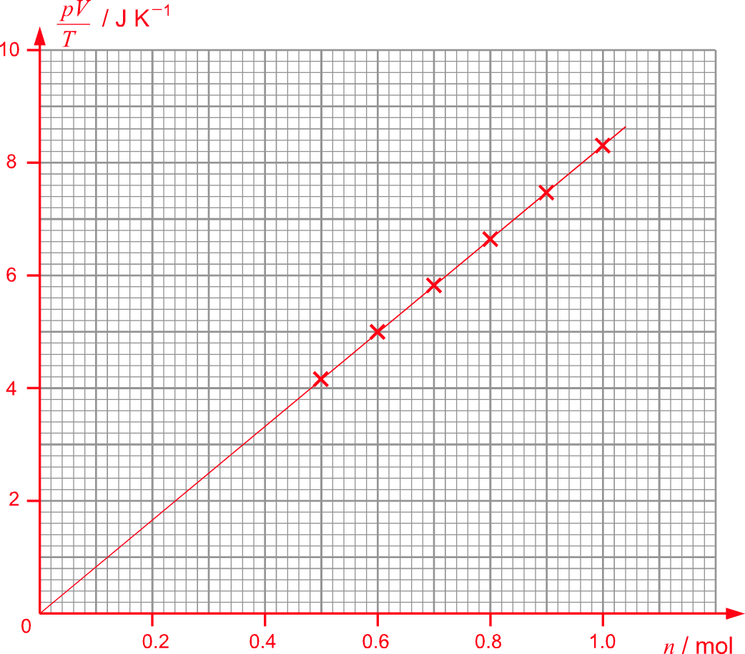
The two quantities are directly proportional to each other.

