C. Ecological Security

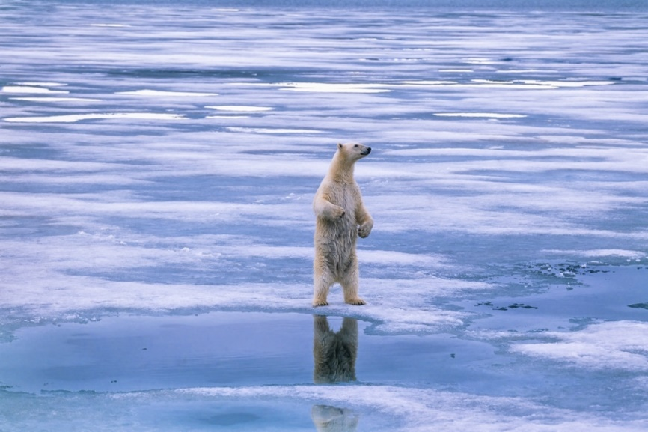1. Polar Bears

Polar bears, a symbol of the Arctic, live in the Arctic and are not found in Antarctic. To learn more about polar bears, we should first understand the food chain of the Arctic. The producers in the Arctic are mostly planktons such as algae and diatoms. The primary consumers are zooplankton such as copepods. The secondary consumers are fish like the arctic cods and larger species like seals. The tertiary consumer is the polar bears.

Polar bears are facing the destruction of habitat due to the loss of sea ice. Polar bears rely on sea ice to prey and store energy during the warmer summer and autumn. As sea ice now melts earlier in the spring and forms later in the autumn, the polar bears live a longer period without food. Their health conditions are worsened. Besides, this also leads to lower reproductive rates, leading to the threat of extinction. The increasing oil exploration in the Arctic also affects the polar bears as the oil can contaminate the water. In other words, they may consume contaminated food and may even be poisoned.

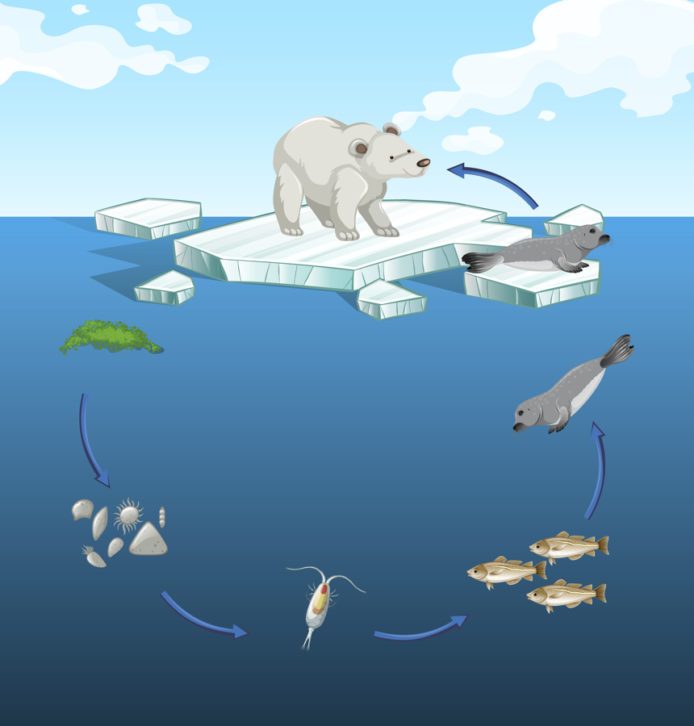

©BlueRingMedia / Shutterstock.com

**Arctic Food Chain**

Algae

Diatoms

Copepod

Arctic cod

Seal

Polar bear

**Fig. 10 |** The Arctic Food Chain

Long-term studies have shown that the polar bear population has dropped by 27% in Canada’s Western Hudson Bay in 5 years. In Southern Beaufort Sea, the subpopulation has even dropped by 40% in 10 years. If the sea ice that the polar bears rely on continues to disappear, polar bears may become extinct by the end of the century. As a result, polar bear is now listed as a vulnerable species, meaning that it is in a high risk of extinction in the Wild.

2. Penguins

Penguins are the signature species of Antarctic. They are flightless birds. Their streamline shape allows them to swim extremely fast in water. Penguins are social creatures, so they often gather into crowd. There are seven species of penguins that reside in Antarctic, known as the Antarctica penguins, namely the Emperors, Adélies, Gentoos, Kings, Chinstraps, Macaroni and Rockhoppers. These Antarctica penguins are cold-adapted.

Emperor penguins are the largest species of penguin on the Earth. Adult Emperor penguins can be as tall as 1.2 m. They head inland to breed, which is the coldest land on the Earth.

Chinstrap penguins are the most aggressive penguins with an average height of 60 cm. There is a line like a strap under their chin.

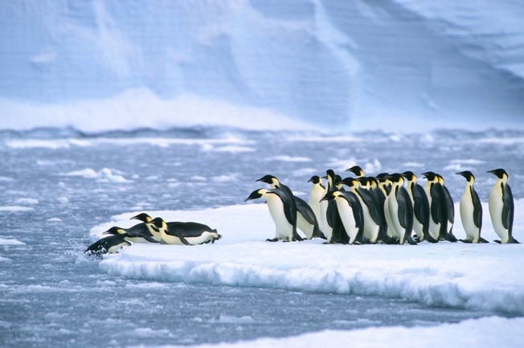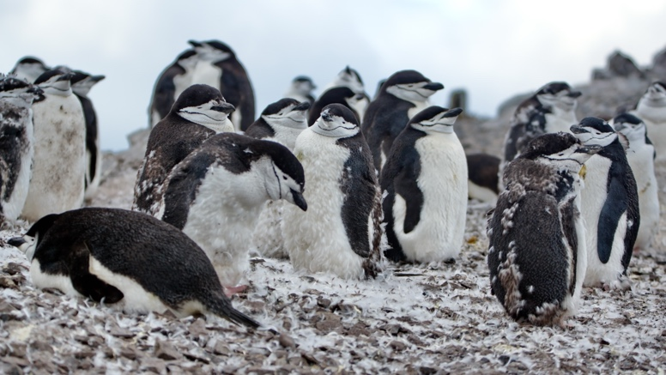

©GTW / Shutterstock.com

©Angela N Perryman / Shutterstock.com

**Fig. 11** | Emperor Penguins (left) and Chinstrap Penguins (right)

As there are fewer species that can adapt to the Antarctic landscape, the food web is relatively simple compared to other ecosystems. Similar to the food chain in the Arctic, planktons are also the producers. The primary consumers are the krills, fishes, squids and birds. The secondary consumers are penguins and seals. The tertiary consumers are the whales.

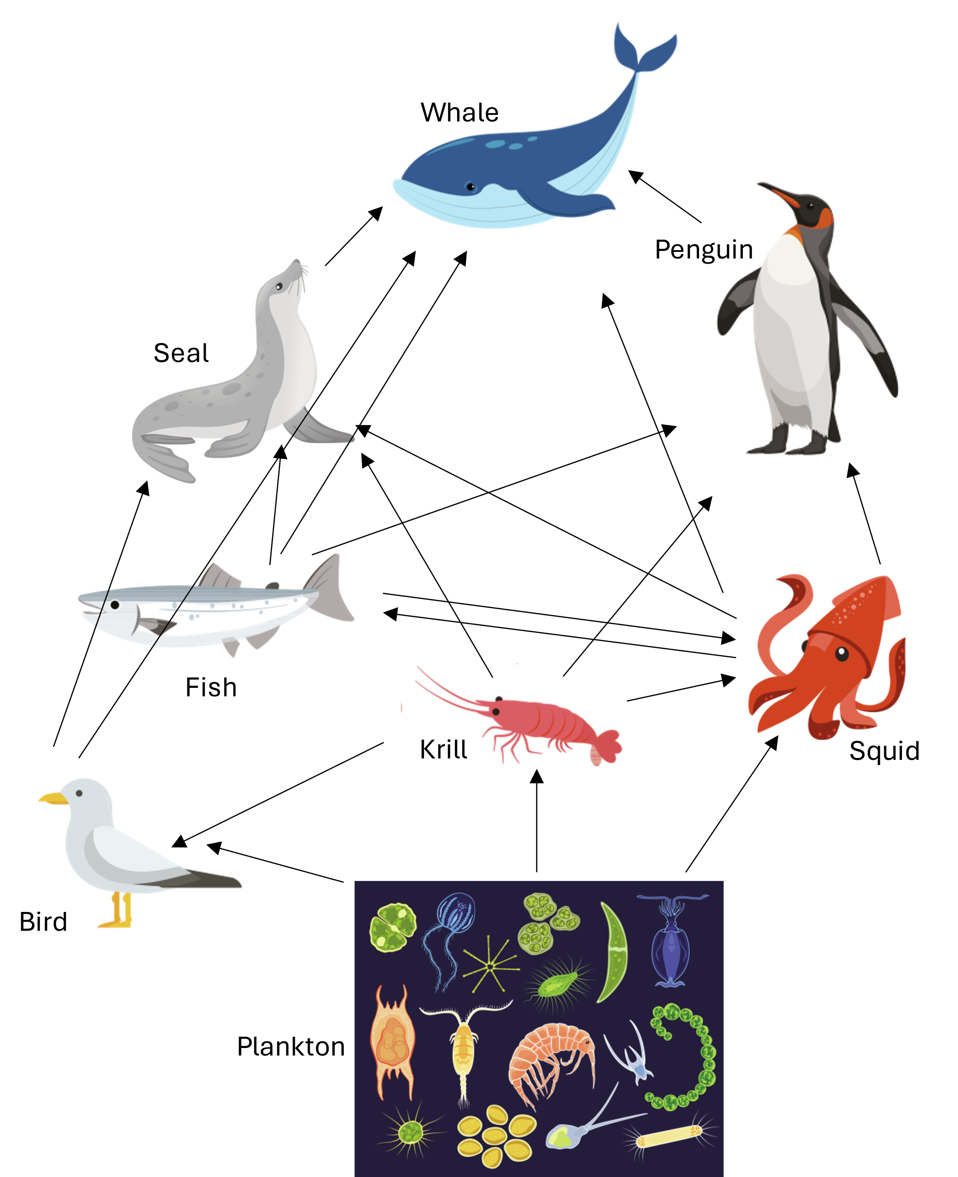

©NotionPic, Alfmaler, Spreadthesign, aliaksei kruhlenia, logistock, Velentina Vectors and KittyVector / Shutterstock.com

**Fig. 12 |** The Antarctic food web

3. Vascular and Non-Vascular Plants

Most of the plants cannot grow under the harsh climate in the polar regions. Yet, some plants are adapted to survive under the extreme conditions.

Vascular plants are plants that have the systems of leaves, stems and roots for transportation of water. In the Arctic, a variety of flowering plants, grasses, and small shrubs can be found. For instance, the Arctic Poppy (*Papaver radicatum*), which can turn its flower to face the sun, and the Dwarf Willow (*Salix herbacea*), one of the world's smallest woody plants are found in the Arctic.

The Antarctic, however, has only two native vascular plant species: the Antarctic hair grass (*Deschampsia antarctica*) and the Antarctic pearlwort (*Colobanthus quitensis*). These species have adapted to grow during the short summer months when temperatures are slightly warmer and the ice retreats.

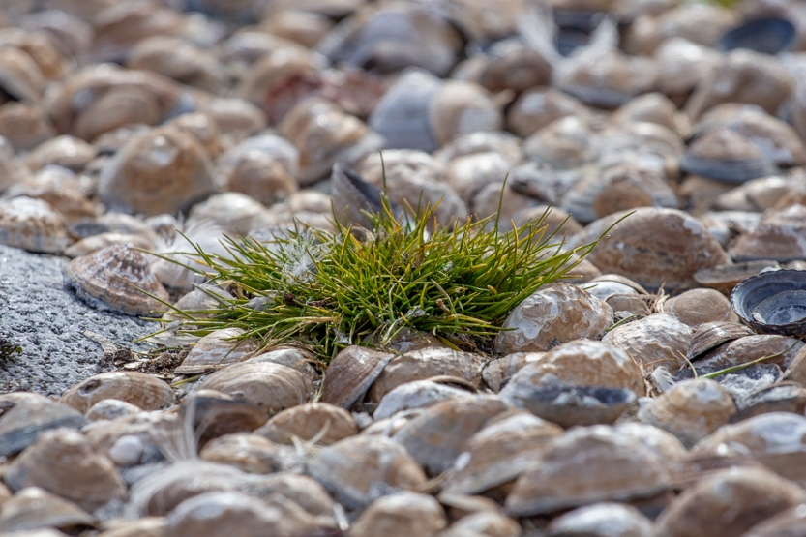

©Viktorialvanets / Shutterstock.com

**Fig. 13 |** Antarctic Hair Grass

Non-vascular plants, which lack the structure for water transportation, are also found in the polar regions. Mosses and liverworts thrive in both the Arctic and Antarctic. In the Arctic, they cover vast areas, forming thick carpets that can store moisture and insulate the ground. For instance, Sphagnum moss and Marchantia liverworts can be found.

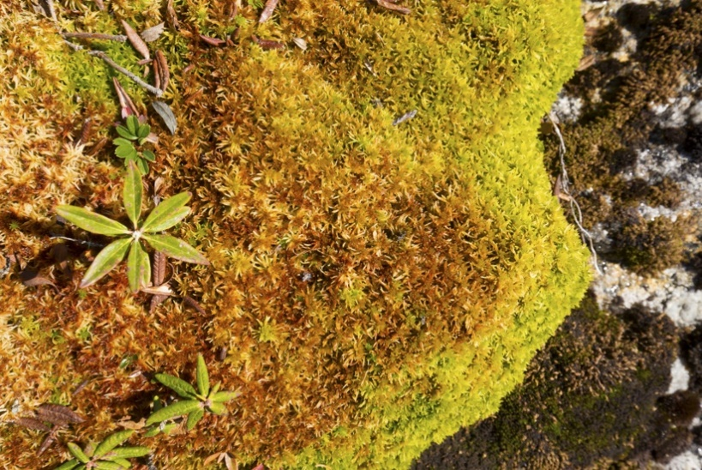

©Jeff Holcombe / Shutterstock.com

**Fig. 14 |** Sphagnum moss in the Arctic

In Antarctica, non-vascular plants are more common than vascular plants because they adapt to the harsher environments better. Antarctic mosses, like *Andreaea regularis*, are found on the continent.

4. Importance of Ecological Security

Ecological security involves the protection of biodiversity and natural habitats to sustain a healthy ecosystem. As mentioned, the polar regions play an important role in the Earth’s climate system. The species found in the Arctic and the Antarctic, specifically adapted to the extreme climate, are precious and crucial to the ecological balance.

To protect the Antarctic, 12 countries signed the Antarctic Treaty in 1959. The Treaty aims to promote peace, safeguard the freedom of scientific investigation and encourage international cooperation. Our country has also ratified the protocols on environmental protection to the Antarctic Treaty.

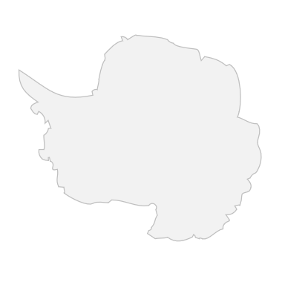

In addition, the Centre for Polar Ecological Conservation was established collaboratively by the Polar Research Institute of China and Shanghai Jiao Tong University. The Centre has aimed to carry out scientific research on the polar ecosystem and the ways to restore the polar ecosystems impacted under the climate change.

Despite the international efforts for maintaining the ecological security in the polar regions, the polar ecosystem still faces several threats. Climate change is the most pressing of these, causing unprecedented rates of ice melt in both the Arctic and the Antarctic. This destroys the habitats of numerous species such as the polar bears and seals. The extraction of natural resources in the polar regions also cause the loss of habitats and other environmental issues such as pollution and disturbances to wildlife.

Furthermore, invasive species, introduced through human activities or changing habitats due to climate change, can outcompete native species and alter the ecological balance.

The database of the Polar Research Institute of China can be accessed online. For more information about living things and the environment in the polar regions, visit the following website.

[https://datacenter.chinare.org.cn/data-center/  
data-resource](https://datacenter.chinare.org.cn/data-center/data-resource)

