Our Earth’s Poles

Overview of National Security Education and related resources

|  |  |
| --- | --- |
| Name | Our Earth’s Poles |
| Related chapters | Chapters 2, 3, 7 and 11 |
| Learning objectives | * Learn about the latitude, landscape, climate and special phenomena of the polar regions * Understand that human activities have great impact on the climate change * Learn about the polar exploration by our country – Polar stations and Xuelong * Know about the animals and plants found in the polar regions and the importance of conservation * Understand the importance of Polar orbiting satellites |
| Learning elements of national security education | Strand one   * Understand the definition of national security and the concepts of ecological security, resource security and polar security in the 13 domains of national security   Strand seven   * Explore topics related to ecological security and new security domain (e.g. biodiversity, conservation, and exploration and protection of deep seas and polar regions) * Understand the impact of human activities on the ecology and environment, and the necessity of safeguarding ecological security and new security domain |
| Suggested teaching and learning activities | * Watch video clips about the differences between the Arctic and the Antarctic, the causes of Polar Day and Polar Night and the impacts of climate change in polar regions * Browse the website to learn about the research conducted by the Polar Research Institute of China |
| Reference | Major Fields of National Security  https://www.nsed.gov.hk/national_security/?l=en&a=national_security_main_focus  Curriculum Framework of National Security Education for Science (Secondary 1-3) (Chinese version only)  <https://www.edb.gov.hk/attachment/tc/curriculum-development/kla/pshe/national-security-education/nse_subject_framework_science.pdf>  TED-Ed  https://ed.ted.com/  NASA Space Place  <https://spaceplace.nasa.gov/>  National Broadcasting Company Los Angeles  https://www.nbclosangeles.com/  National Geographic  https://www.nationalgeographic.com/  South China Morning Post  <https://www.scmp.com/> Polar Research Institute of China  [https://en.pric.org.cn](https://en.pric.org.cn/) |

Our Earth’s Poles

A. Introduction

1. Latitude and landscape

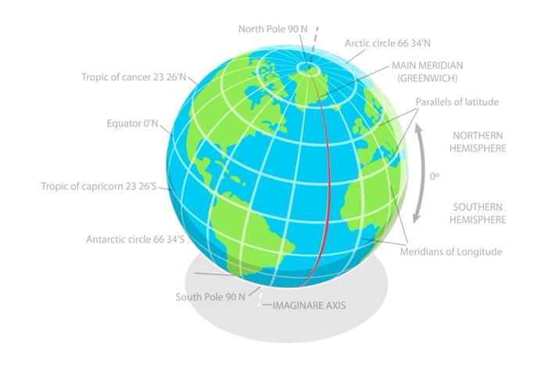

©TarikVision / Shutterstock.com

Antarctic Circle 66.6° S

North Pole 90° N

Arctic Circle 66.6° N

Tropic of Cancer 23.4° N

Equator 0° N

Tropic of Capricorn 23.4° S

Southern Hemisphere

Northern Hemisphere

South Pole 90° S

**Fig. 1 |** The globe

The Earth’s Poles, comprising the North Pole and the South Pole, are Earth’s extreme north and south points. The North Pole, situated at 90° North latitude, lies in the Arctic Ocean (北冰洋) while the South Pole, at 90° South latitude, is on Antarctica (南極洲).

The polar regions are regions located at the planet’s extremities that surround the poles, encompassing areas from 66.6° North and South latitudes to the poles at 90° North and South latitudes respectively. The Arctic is the region extending from North Pole south to the Arctic Circle, including parts of Norway, Sweden, Finland, Russia, the United States, Canada, Greenland and Iceland. Antarctica, the southernmost continent on the Earth, ranks as the fifth largest continent on the Earth.

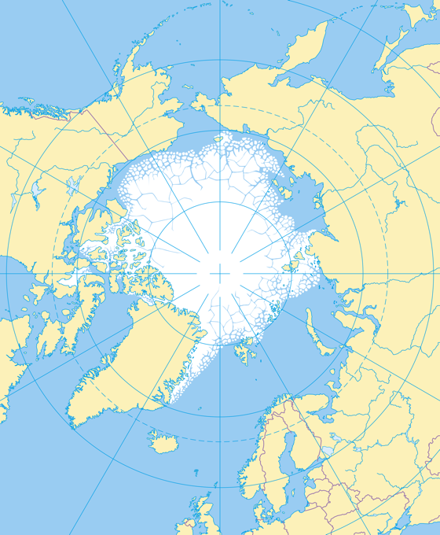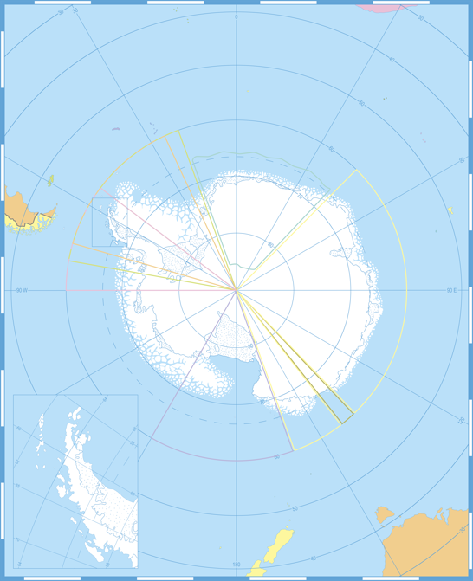

©Peter Hermes Furian / Shutterstock.com

©Porcupen / Shutterstock.com

Alaska (U.S.)

Canada

Russia

Greenland (Denmark)

Finland

Sweden

Norway

Iceland

North Pole

Arctic Circle (dotted)

South Atlantic Ocean

Indian Ocean

South Pacific Ocean

South Pacific Ocean

Antarctic Circle (dotted)

South Pole

**Fig. 2 |** The Arctic (left) and the Antarctic (right)

The permafrost (凍土) in polar regions is a layer of soil that remains under 0 °C for a substantial period. There are ice floes (浮冰) which are large packs of floating ice on the Ocean in the polar regions.

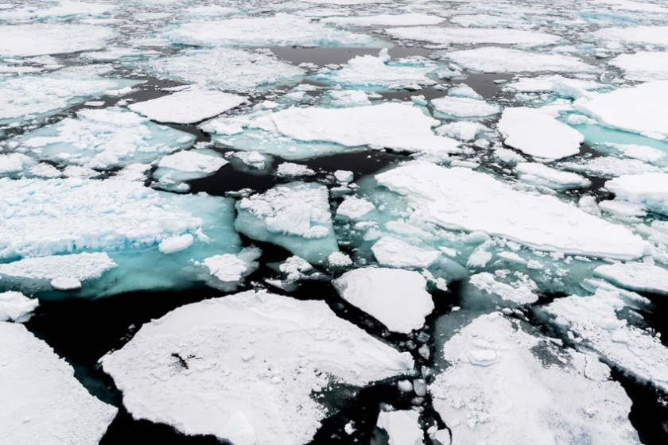

©Anton_Ivanov / 123RF.com

**Fig. 3** | Ice floes in the Arctic

Watch the following video and learn more about the Arctic and Antarctic.

**TED-Ed – The Arctic vs. the Antarctic**

https://youtu.be/Z5VRoGTF60s

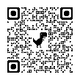

Discussion

**1.** Compare and contrast the Arctic and the Antarctic in terms of where they are situated in.

_______________________________________________________________________________________________________________________________________________________________________________________________________________________________________________________________________________________________________

* The Arctic is situated in the Northern hemisphere while the Antarctic is in the Southern hemisphere.
* The Arctic lies in the Arctic Ocean surrounded by land while the Antarctic is a continent surrounded by the ocean.

**2.** Give THREE examples of lives in the Arctic.

_________________________________________________________________________________________________________________________________________________________________________________

Zooplankton, phytoplankton, fish, marine mammals, birds, land animals, human societies (any three)

**3.** Give THREE examples of lives in Antarctic.

_________________________________________________________________________________________________________________________________________________________________________________

Algae, cold-adapted animals, bacteria, fungi, protista (any three)

2. Climate

The polar regions experience a unique climate with no distinct seasons, characterized by long, cold winters and short, cool summers. During Winter, the average temperature ranges from −30 °C to −55 °C while in summer, it may reach 10 °C. Generally, the Arctic is slightly warmer than the Antarctic. Additionally, it is extremely dry in the Antarctic, with a relative humidity of air as low as 0.03%. The extreme climate makes the polar regions an inhospitable natural environment on the Earth for human habitation. It is also rare to see living things in the polar regions.

3. Special Phenomenon

a. Aurora

The aurora (極光), often known as the northern lights and the southern lights, is the spectacular light display in the sky, featuring shades of green, and occasionally red, yellow, orange and blue. Auroras result from the collision between particles of the solar wind and gases, such as nitrogen and oxygen. When the particles of the solar wind collide with atoms of different gases, auroras of different colours are produced.

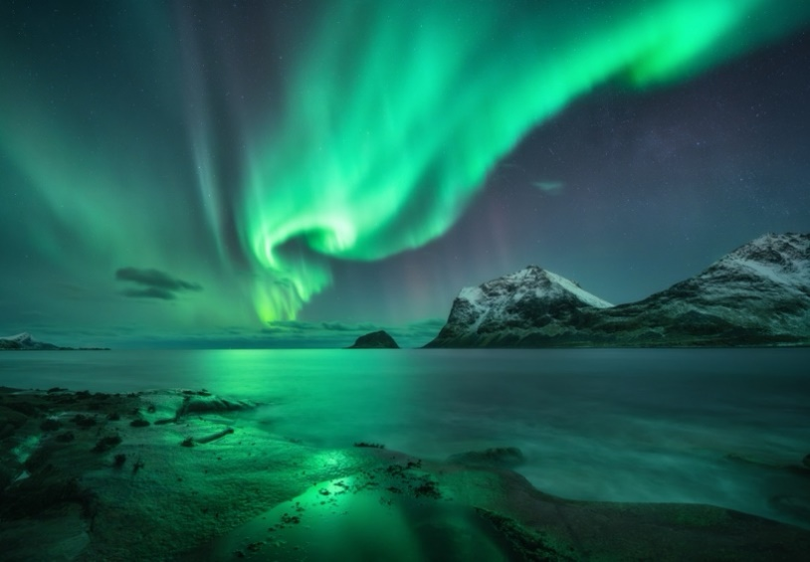

©Denis Belitsky / Shutterstock.com

Watch the following video to learn about the formation of aurora.

<https://youtu.be/PgIKsuZ3RZU>



**Fig. 4 |** Northern lights in Norway

b. Polar Day and Polar Night

Polar Day is a phenomenon when the Sun remains above the horizon for more than 24 hours. Conversely, Polar Night occurs where night lasts for more than 24 hours. In the Arctic, there is no sunlight since early October until early March of next year. In the Antarctic, polar night lasts from early April to late August.

The cause of Polar Day and Polar Night can be attributed to Earth's axial tilt and its orbit around the Sun. The Earth tilts at an angle of about 23.5° relative to its orbital plane. Hence, for several months each year, as the Earth orbits around the Sun, the poles are either tilted towards or away from the Sun.

During the seasons when the pole tilts towards the Sun, the polar region experiences Polar Days. Meanwhile, the other pole tilts away from the Sun, experiencing the Polar Nights.

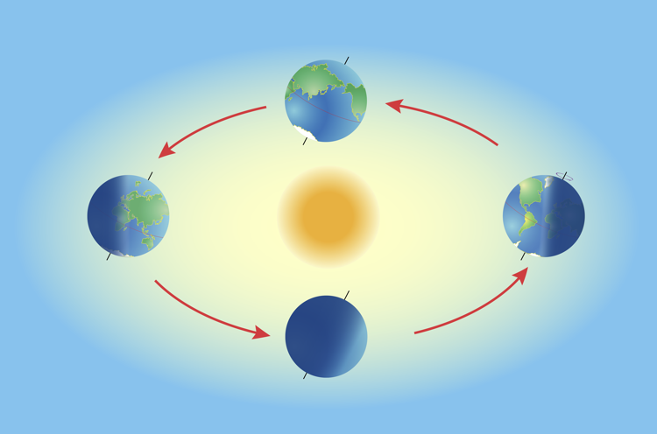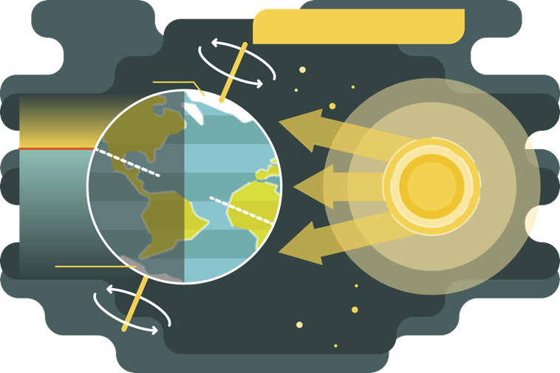

Polar Day

Polar Night

Night

Day

Winter

Summer

Day and Night Cycle

Polar Day

Polar Night

Day

Night

Summer

Winter

©Designua / Shutterstock.com

©VectorMine / Shutterstock.com

**Fig. 5 |**  The Earth’s rotation (left) and Polar Day and Night (right)

Watch the following video to learn more about Polar Day and Polar Night in the Arctic.

**NBCLA – Let Me Explain: What is Polar Night?**

https://www.youtube.com/watch?v=0baB5pjR2Lc



Discussion

**1.** Briefly describe the cause of Polar Day and Polar Night in the Arctic.

As the Earth orbits around the Sun, the Earth’s axis is tilted. During winter, the North Pole is tilted away from the Sun, giving rise to the Polar Night. During summer, the North Pole is tilted towards the Sun, giving rise to the Polar Day.

____________________________________________________________________________________________________________________________________________________________________________________________________________________________________________